2nd Metatarsal Stress Fractures

Anatomy
Your 2nd metatarsal bone is a long bone in your feet, and in most of the population, the longest of the metatarsal bones. It is subject to high forces when walking, running and throughout sports. Along with the 3rd metatarsal, it is the most common areas of stress fractures in the foot. Other sites include your calcaneus (heel bone), fibula (outer bone of the lower leg and ankle) and navicular (bone on top of the midfoot).

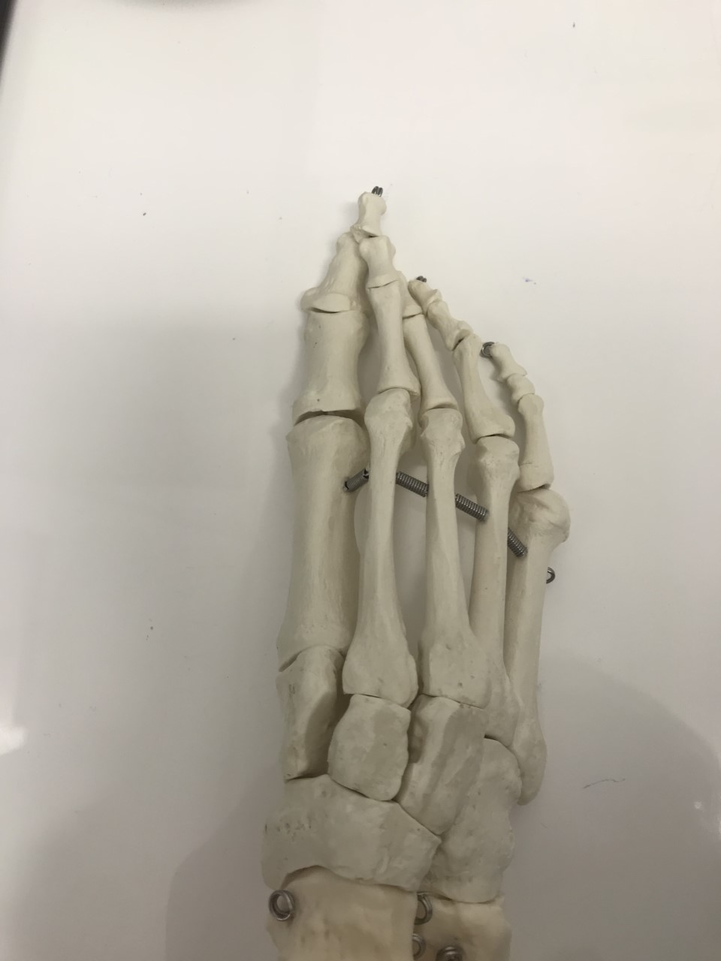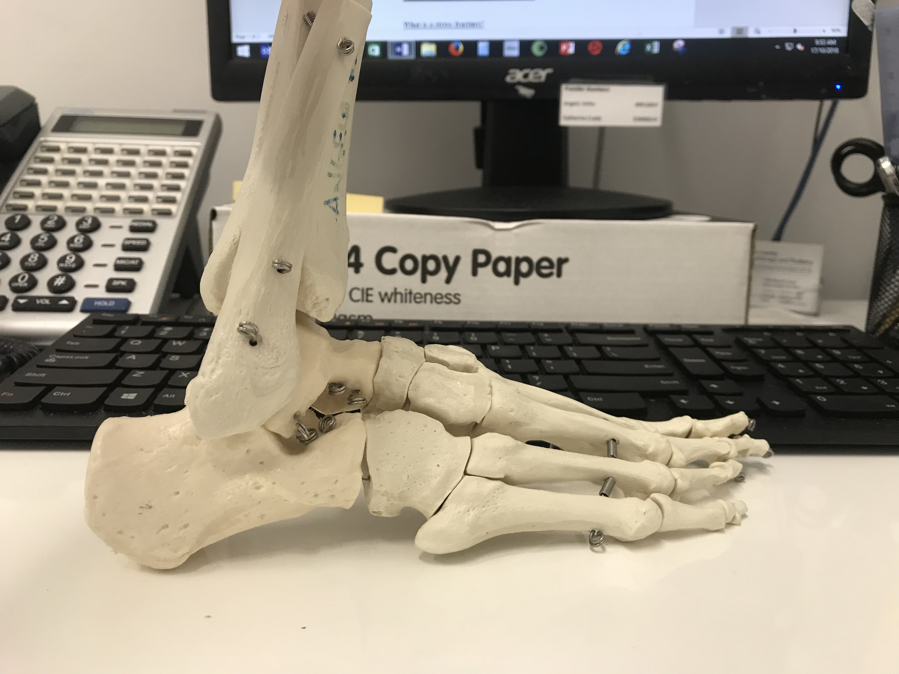
Calcaneus
Fibula
Navicular
2nd Metatarsal of the right foot
What is a stress fracture?
A stress fracture is classified as a small crack or severe bruising within a bone. Majority of stress fractures are a result of overuse and repetitive activity and are extremely common in runners and athletes involved in heavy impact sports such as basketball, football, netball and cricket.

Stress fractures also result from a change in activity – attempting a new exercise and suddenly increasing intensity of an exercise. A change in footwear can also result in increased stress on the 2nd metatarsal. When an exercise is repeated too often, the bones and supporting muscles do not have enough time to heal between sessions. This is due to a process called remodeling. Bone is in a constant state of turnover, where new bone develops and replaces old bone. If an exercise is performed too frequently, the breakdown of old bone occurs rapidly and the new bone is unable to repair and replace it. This results in bone weakening.

People with a variety of systemic issues that result in reduction of bone density and strength are also at risk of developing stress fractures. Such diseases include osteoporosis, diabetes mellitus and Vitamin D deficiency.

Refraining from high impact activities for a period of time is key to recovery. Returning to activity too quickly an impede and delay healing time, and potentially cause a complete fracture of the bone. Should this occur, it will take far longer to recover and may require surgical intervention.

Symptoms
The most common symptom with stress fractures is PAIN. It generally develops gradually and worsens with weight-bearing exercise.

Other symptoms include:
- Swelling on top of the foot
- Discolouration/bruising
- Tenderness to palpate the area
- Pain that reduces when at rest

If any of these symptoms arise, we recommend you see either your GP, podiatrist or physiotherapist ASAP, as ignoring the pain can have serious consequences, such as complete fracture of the bone. In the meantime, we recommend following the RICE protocol – REST, ICE, COMPRESSION, ELEVATION. Painkillers and anti-inflammatory cream/tablets help to relieve swelling and pain.

What we can do
Both our physiotherapists and podiatrists are trained and qualified to diagnose and treat stress fractures of the foot and ankle. A physical examination is performed, and a thorough medical history is taken to determine any risk factors for stress fracture. We may order imaging tests to help confirm a diagnosis, such as x-rays, bone scans, and MRI’s. Often, stress fractures are unable to be picked up on an x-ray until 2 weeks post-injury.

If you’ve suffered from multiple stress fractures in the same area, or elsewhere in your body, we may send you to your GP for a full work-up, including blood tests to check for nutritional deficiency such as Vitamin D and calcium.

Treatment
The primary goal of treatment is to relieve pain and ensure the bone is correctly healing. Treatment varies on where the stress fracture is, and its severity.

Non-surgical treatment involves:
- Modified activities – switching to non-weight-bearing activity such as swimming or cycling.
- Footwear – wearing cushioned, supportive shoes as much as possible
- Moon boot and/or crutches – for non-weight-bearing and reduction of stress on the site of fracture

Surgical treatment may be required should the stress fracture not heal properly. Surgical intervention requires a process called internal fixation, whereas pins, screws and/or plates are inserted into the bones to hold it together during the healing process.

Generally, healing time for stress fractures is between 6-8 weeks. We often refer for follow-up x-rays every 3-4 weeks to confirm healing of the stress fracture, and may refer for CT imaging, which can be more useful to confirm healing. Once the stress fracture has healed, we will allow a gradual return to activity, and utilise rehabilitation programs to ensure there is no hiccup in your recovery. As your fitness levels increase, we can slowly increase the duration, frequency and intensity of your exercise.

