Bunions

Anatomy

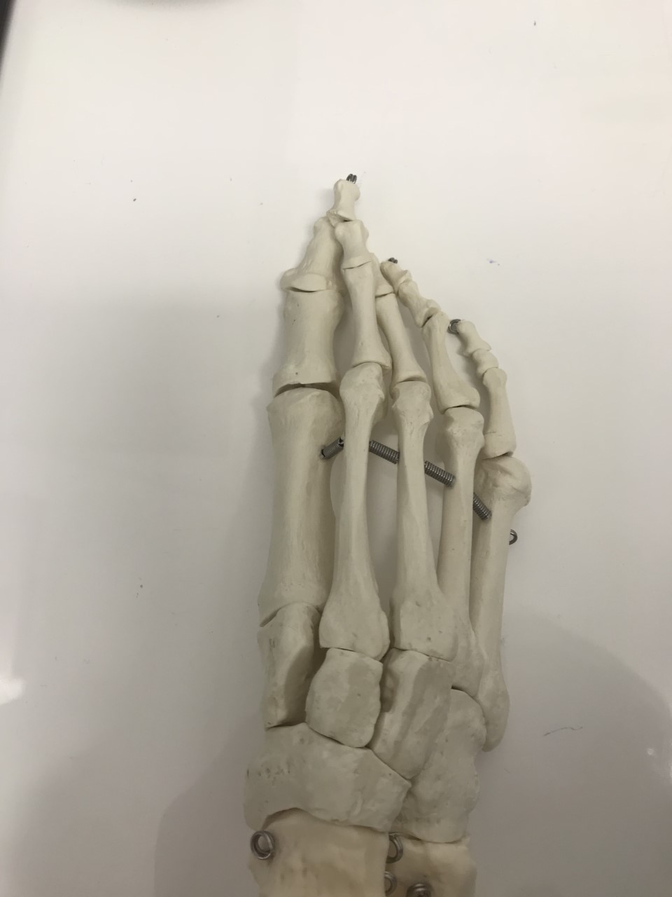
Site of Bunion formation
1st Metatarsal of the right foot

What is a bunion?
A bunion, or Hallux Abducto-Valgus, is a ‘deformity’ of the 1st metatarso-phalangeal joint. It is often characterised by a bony bump on the inside of your 1st joint and deviation of the 1st toe. It is an extremely common problem, and often affects women more so than men.

Long-term and without the proper intervention, the 1st toe can often start to cross over or under the 2nd digit, resulting in pain and deformity of the 2nd toe. The strong ligaments, muscles and tendons that strengthen the joints start to weaken, leading to further deformity and a change in your gait. The stages of bunion formation are as below:
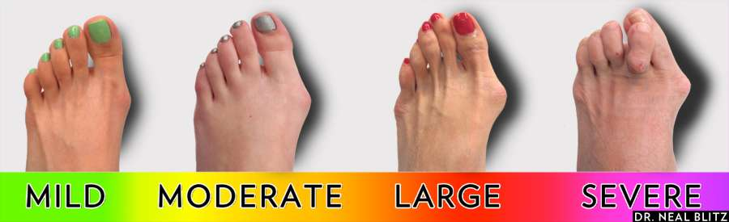

Causes of Bunions
Bunions result from a combination of lifestyle, genetics, biomechanics and less commonly, trauma to the toe. Women are more prone to bunion formation than men.

Common causes include:
- Poor footwear – tight fitting, too flat, high heels
- Poor foot mechanics – flat footed, excessive collapsing of the arch
- Poor biomechanics – muscular deficiency at the level of the hip, knee and ankle
- Genetics

Symptoms
The most common symptom with bunions is pain, swelling, and discolouration of the joint. Often, patients will start to notice deviation of the 1st toe, and a more pronounced bump at the joint line. This often leads to an inability to wear closed-in footwear. Other symptoms include formation of callus (hard skin) over the skin, and increased pressure on the toenail, often resulting in ingrown toenail pain.

What we can do
Here at Mount Lawley Physiotherapy and Podiatry, our podiatrists are highly trained experts in the anatomy and biomechanics of the foot and ankle. We provide a thorough physical and medical examination to determine the causative factors of bunions, before tailoring a treatment plan specifically for you.

Initial assessment is to determine muscular and joint health, along with assessing your footwear and lifestyle. We perform a gait examination to determine any other causative factors that may be stemming from your hip, knee and/or ankle. We perform range of motion testing, and ensure you have a complete understanding of how your bunions have likely formed.

We also refer for x-ray and ultrasound studies to further determine the health of the joint.

Treatment
The primary goal of treatment is to relieve pain and swelling. Unfortunately, without surgical intervention we are unable to ‘straighten’ the toe. However, with conservative care we can stop the progress of the bunion. We often attempt to exhaust all forms of conservative care first before looking at a surgical approach.

Non-surgical treatment involves:
- Modified activities – switching to non-weight-bearing activity such as swimming or cycling to relieve some pressure on the 1st toe for the first few weeks
- Footwear – wearing cushioned, supportive shoes as much as possible
- Muscular release
- Joint mobilisation to increase range-of-motion
- Strapping
- Orthotics – custom-made orthotics help to re-align your foot position and gait, taking pressure off your first toe and allowing it to function better
- Strengthening of the joint using isolated exercises

Surgical treatment may be required should conservative care fail. We utilise podiatric surgeons and orthopaedic surgeons in Western Australia for all surgical management.

If you or anyone you know may be suffering from bunions, refer them to Mount Lawley Podiatry and see our qualified podiatrists for a full assessment. We will strive to ensure you are walking better for longer.

